May 19, 2017

Director Mac Burdette
Patriots Point Development Authority
40 Patriots Point Rd.
Mt. Pleasant, South Carolina 29464

RE: Legislative Oversight Study of Patriots Point Development Authority

Dear Director Burdette:

On May 10, 2017, the House Legislative Oversight Committee approved Patriot’s Point Development Authority for review, investigation and study. In conducting studies, it is the Legislative Oversight Committee’s goal to partner with the agency to help it identify areas in which it can continue to improve upon the positive results it has generated for the people of South Carolina.

In the near future, the Committee will schedule a meeting with your agency to discuss preliminary matters relating to the agency. The agency will have an opportunity provide a brief overview of its programs and ask questions. Also, please do not hesitate to contact Committee staff at any time with questions.

The Committee wants to ensure the agency has as much information as possible and ample opportunity to review materials prior to the meeting. Therefore, enclosed is a flow chart with an overview of the process the Committee intends to follow, copy of the Committee’s Rules and copy of the Committee’s Standard Practices (please note these may be modified). Also, below is a brief summary of the Committee’s expectations.

The Committee expects the following of each agency under study:
- Inform its staff that the agency is undergoing the legislative oversight study process as well as the purpose of the study;
- Appoint a liaison to assist the Committee with all activities;
- Respond to its requests in a concise, complete and timely manner;

Page Two
Director Burdette

- Be candid with the Committee and promptly discuss with the Committee any concerns or questions the agency may have related to the legislative oversight study process, including any concerns the agency may have that the Committee has drawn an incorrect conclusion;
- Realize written information provided to the Committee is considered sworn testimony pursuant to SC Code Ann. Section 2-2-70; and
- Inform the Committee if any information requested by the Committee, or provided by the agency, cannot be published online due to provisions in contract or law.

Enclosed please find information to share with agency employees in the manner in which the agency regularly communicates with its employees.

I hope the information above and enclosed is helpful to you and your agency in understanding the process the Committee intends to following in conducting its study and investigation process.

Sincerely,

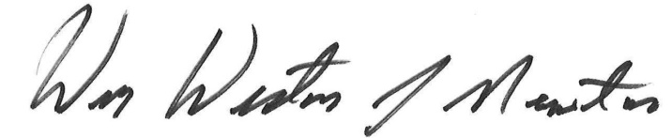

Wm. Weston J. Newton
Chairman, House Legislative Oversight Committee

Enclosures

cc: House Legislative Oversight Committee
Mr. Ray Chandler, Board Chairman
Mr. Wayne Adams, Board Vice-Chairman
Ms. Susan Marlowe, Board Member
Mr. Edwin S. Taylor, Board Member
Mr. Richard Wilkerson, Board Member
Mr. Zeb C. Williams, Board Member
Mr. Spencer King, Board Member
Mayor Linda Page, Board Member

